CALGARY STAMPEDE, THE ROCKIES
& ALASKAN CRUISE

DATE: 05 JULY 2019
Special Tour

DURATION: 11 days (+ optional Alaskan Cruise)
DEPARTURE: Belfast/Dublin (subject to availability)
TOUR ESCORTED BY: SHARON FLEMING
TOUR TYPE: CULTURE
PRICE: from £2479 per person (based on 2 sharing)
£500 Single Supplement

05 – 15 July 2019 (23 July 2019 if cruise included)

5 July 2019 Arrival to Calgary

Depart Dublin for your onward flight to Calgary. On arrival in Calgary you will transfer to your hotel to check in and relax for the evening. Dinner is included so you will have a great opportunity to meet up with other travellers on the trip.

Meals included: Dinner

6 July 2019 Calgary

We set off in the morning to enjoy a panoramic tour of Calgary followed by the ascension of Calgary Tower where you can explore Calgary's magnificent landmark. Once at the Observation Deck you will be able to view downtown's glittering skyscrapers and the majestic Rocky Mountains. You will then have the afternoon to spend at your leisure.
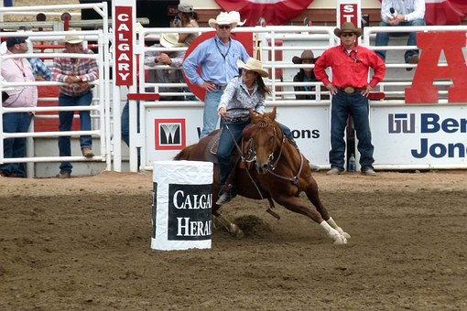
In the evening we will be enjoying the Calgary Stampede Evening Show, this unique entertainment doubleheader that takes place nightly at 7:45 PM. The blast of a klaxon kicks off the GMC Rangeland Derby, featuring nine heats of four chuckwagons each—excitement that’s measured on the Richter Scale. When the last wagon thunders over the finish line, the Calgary Stampede Grandstand Show dazzles audiences with elaborate song and dance numbers, acrobatics, and concludes with a spectacular fireworks finale!

Meals included: Breakfast, Dinner

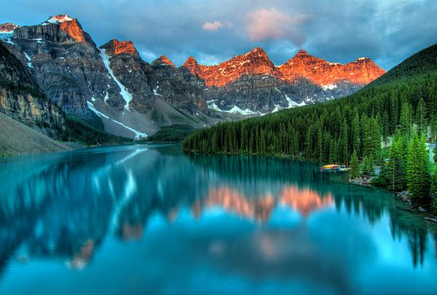

7 July 2019 Calgary – Banff
We depart Calgary in the morning and head west to Banff and take it the sights with a panoramic tour. Following lunch at your leisure we continue our tour of Banff with a visit to the Banff National Park and Yoho National Park with scenic stops along the way to take in the breath-taking scenery.

This evening we will be dining at Wild Bill’s Saloon located in the centre of downtown Banff, Wild Bills Legendary Saloon is a longstanding institution serving heart-warming, western hospitality and the best BBQ and country comfort food in Banff.

Meals included: Breakfast, Dinner

8 July 2019 Banff – Lake Louise – Jasper

This morning we make our way to Lake Louise. Lake Louise is world famous for its turquoise lakes, the Victoria Glacier and soaring mountain backdrop. Surrounded by a lifetime’s worth of jaw-dropping sights and adventures, Lake Louise is a rare place that must be experienced to be believed. Followed by lunch at your leisure.

Discover the power of nature with the included Snow coach Adventure excursion – the must-do experience in the Canadian Rockies. At the heart of the incredible Icefields Parkway is one of the largest non-polar ice fields in the world. Here, you’ll travel on a massive Ice Explorer to a place where you can walk on, feel and drink from the Athabasca Glacier.

We round off todays trip with a stop at the Athabasca Falls before heading to Jasper for our overnight stay.

Meals included: Breakfast, Dinner

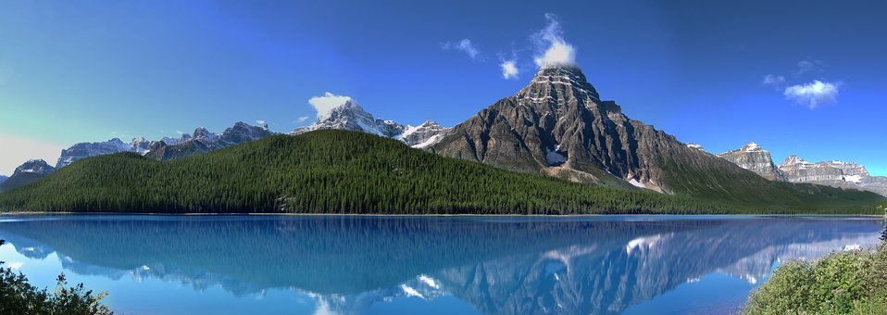

9 July 2019 Jasper

We begin today with an orientation tour of Jasper then we head off to the majestic Lake Maligne which is the second-largest glacier-fed lake in the world to enjoy a scenic cruise. Make sure to bring your camera: it’s one of the most photogenic places in Jasper National Park!. Followed by lunch at your leisure. Then it’s off to Maligne Canyon where you can walk along the self-guided trail across the gorge to enjoy spectacular views. Free time is provided this afternoon to discover the area at your own pace.

Meals included: Breakfast, Dinner

10 July 2019 Jasper – Sun Peaks
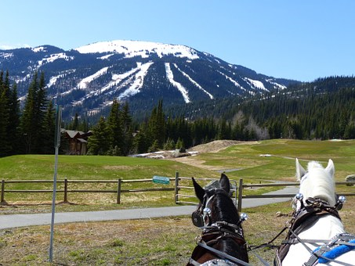

We depart towards Kamloops on the scenic Coquihally Highway, following the salmon river of the same name until we reach Wells Gray Park to stop at the Spahat Water Falls. Volcanic rock deposits left centuries ago form the layer-cake-like canyon at Spahats Falls, making it one of the most dramatic waterfalls to photograph in the Park. Followed by lunch at your leisure.

We then continue towards Sun Peaks where you can enjoy the evening at your leisure.

Meals included: Breakfast, Dinner

11 July 2019 Sun Peaks – Whistler
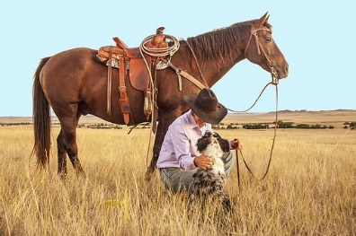
After Breakfast we start to make our way towards Whistler through the rugged cowboy and ranch country of Cache Creek where we pay a visit to Cache Creek Ranch before travelling across the Marble Canyon in Lillooet. Followed by lunch at your leisure.

Upon arriving into Whistler, we have our orientation tour to acquaint you with the beautiful village. Whatever you are looking for whether it be Art galleries, Restaurants or locals’ favourite spots, you’ll be able to get your bearing and see what there is in Whistler.

Meals included: Breakfast, Dinner

12 July 2019 Whistler – Vancouver

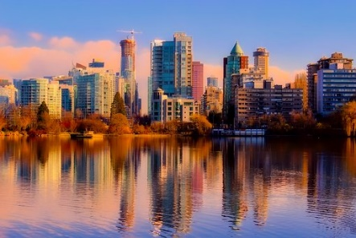
Leaving Whistler for Vancouver this morning. Upon arrival spend the afternoon with some free time to discover the endless supply of attractions and things to see and do. From colourful downtown neighbourhoods, to culturally diverse suburbs and mountainside districts, there’s plenty to explore!

Meals included: Breakfast, Dinner

13 July 2019 Vancouver
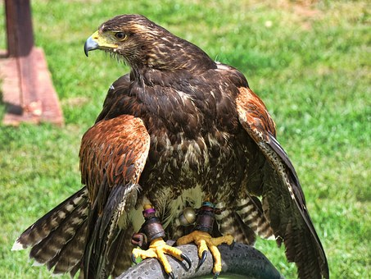
Today we take a city tour of Vancouver, or the ‘Pearl of the Pacific’ as it’s known. During your tour, you will explore Chinatown, Gastown Canada Place and Granville Island Market. We then visit Stanley Park, a beautiful 1000-acre park at the edge of the city's downtown core. Followed by lunch and the rest of the afternoon at your leisure.

This evening we will be dining at Vancouver’s Steamworks restaurant that gets its name from the famous Gastown steam line that runs through the premises. Meals included: Breakfast, Dinner
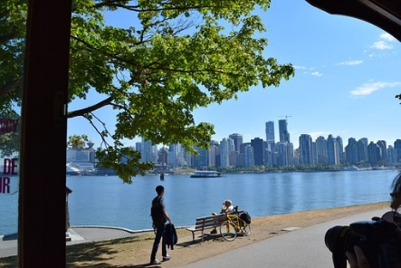
14 July 2019 Vancouver – Airport / Cruise Terminal
Today we have free time to enjoy Vancouver before our transfer to the airport for the return flight to Dublin, or if you are joining our optional Alaskan cruise, you will be transferred to the cruise terminal.

15 July 2019 Arrive Dublin

80% of our customers who travel through the Canadian Rockies, finish their trip with the amazing cruise to Alaska.
Mr & Mrs K 25th wedding anniversary ‘Thank you for all your expert advice on our trip to Canada. You left no stone unturned in detail and your recommendation to add the Alaskan cruise was indeed the right one. That part of the world discovered, now where are you sending us next?’ June 2016

OPTIONAL ALASKA HUBBARD GLACIER CRUISE

Celebrity Cruises
Celebrity Eclipse
7 Nights – All meals included

14 July 2019 Vancouver
Embark Celebrity Eclipse.

15 July 2019 Inside Passage (Cruising)
The dramatic scenery of the Inside Passage has been shaped by glaciers for millions of years. The terrain here is verdant and vivid – mysterious forests blanket the towering mountains.

16 July 2019 Icy Strait Point
Go whale watching, learn Tinglit tribal customs or fly high above Port Frederick on a zip-rider. Later, tuck into the ultimate halibut and chips at the Hoonah Packing Company cannery.

17 July 2019 Hubbard Glacier (Cruising)
The largest calving glacier on the North American continent, Hubbard Glacier calves off icebergs as high as 10-story buildings. This sends blocks of ice into the sea every few minutes.

18 July 2019 Juneau
Some sightseeing is best done from above. View the majestic Mendenhall Glacier from the East Glacier Loop Trail, or sail via gondola to Mount Roberts. Don’t miss the crab cakes.

19 July 2019 Ketchikan
Experience Eden first-hand. Kayak saltwater fjords fringed by forests, keeping an eye out for black bears and porpoises. Tour the great outdoors by foot, bike or zipline.

20 July 2019 Inside Passage (Cruising)
The dramatic scenery of the Inside Passage has been shaped by glaciers for millions of years. The terrain here is verdant and vivid – mysterious forests blanket the towering mountains.

21 July 2019 Arrive Vancouver
Arrive in Vancouver where you will be transferred to the airport for your flight back to Dublin.

PRICE
+£1195 per person Inside Stateroom – (Single Supplement +£1950)
+£1595 per person Non-Obstructed Balcony Stateroom – (Single supplement +£2800)

What’s included: -

- RETURN FLIGHTS
- 23KGS OF LUGGAGE PER PERSON PLUS 1 PIECE OF HAND LUGGAGE
- TOUR ESCORTED BY SHARON FLEMING
- LOCAL GUIDE THROUGHOUT
- FULLY AIR-CONDITIONED COACH
- Entrance fees where mentioned in itinerary
- Bed & Breakfast AND 8 EVENING MEALS
- Overnights at hotel (ALL HOTELS ARE 3* OR 3* SUPERIOR)
- SERVICES OF A LOCAL GUIDE THROUGHOUT THE TOUR
- ENTRANCE TICKETS TO CHUCKWAGON RACES
- ALL MEALS INCLUDED ON CRUISE
- PORT CHARGES AND TAXES INCLUDED ON CRUISE

Not included:-

- Items of a personal nature
- Personal Insurance
- Tips & gratuities (£8pp PER DAY FOR GUIDE AND COACH DRIVER) – TIPS & GRATUITIES INCLUDED ON CRUISE

